Phase 4: Process Automation (Admin)

# 🎯 Objective

Automate order lifecycle processes in Salesforce (from creation → approval → fulfillment → delivery updates) to minimize manual dependency, ensure accuracy, and provide transparency for both retailers and wholesalers.

# 1. Validation Rules

Ensure data quality by preventing invalid or incomplete records.

* • Order Object
* - Prevent “Dispatched” status if Delivery Date is blank.
* - Ensure Retailer__c field is always filled when creating an Order.

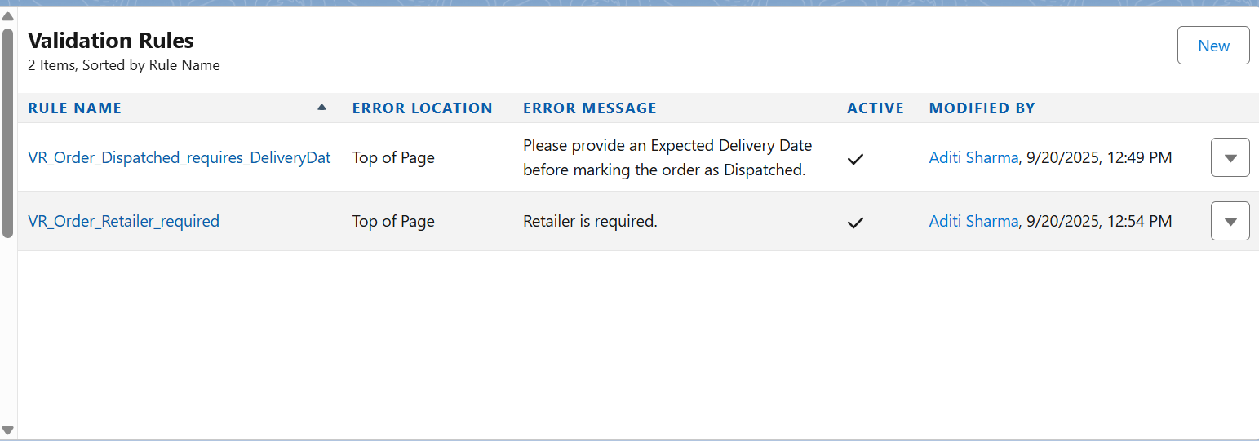

* • Inventory Object
* - Prevent Order creation if Available_Quantity < Ordered_Quantity.

📌 Example Rule:

ISCHANGED(Status__c) && ISPICKVAL(Status__c, "Dispatched") && ISBLANK(Expected_Delivery_Date__c)

# 2. Workflow Rules (for simple automation)

* • Send email alerts when:
* - New order is placed (Retailer gets confirmation email).
* - Order is marked “Delivered” (Retailer gets delivery notification).

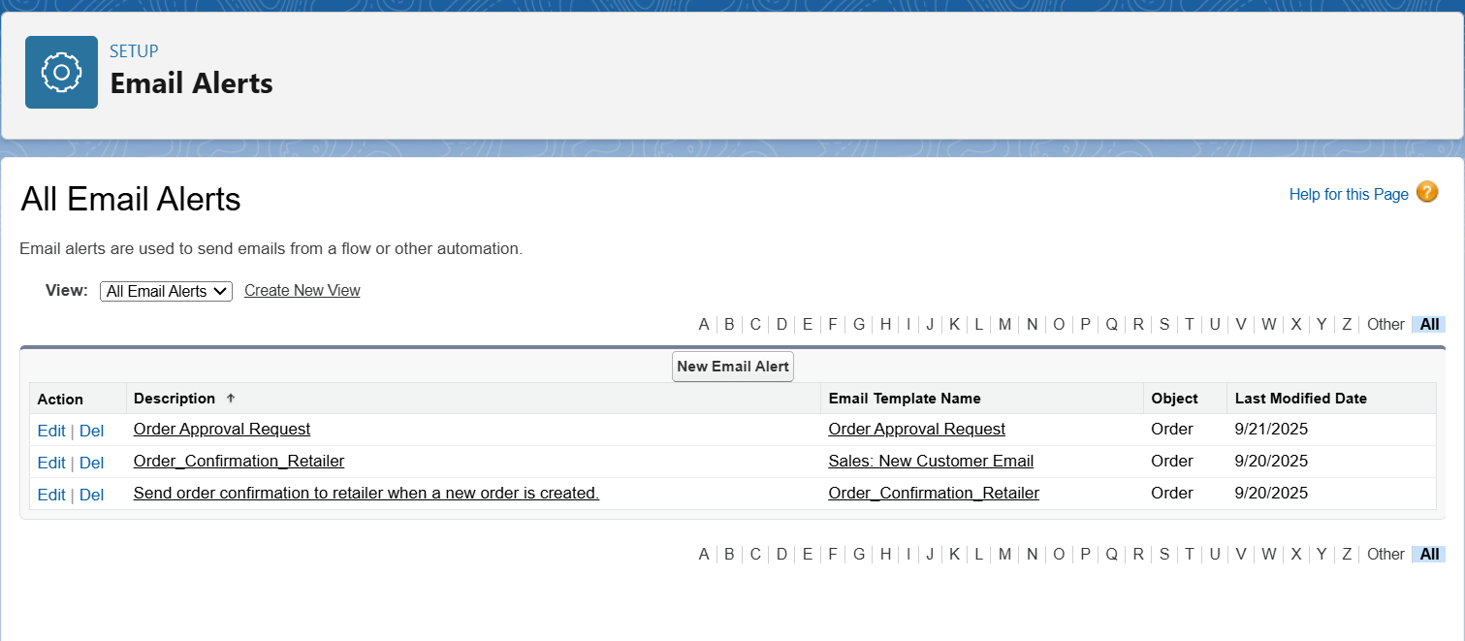

# 3. Process Builder (complex record updates)

* • When an Order is created, auto-update Order Status = New.
* • When Order Status changes → Dispatched, create a Delivery record automatically.
* • When Payment_Status = Paid, update Finance_Approval__c = True.

# 4. Approval Process

* • Use for high-value orders (e.g., > $50,000).
* • Flow:
* - Order Submitted → Goes to Sales Manager for approval.
* - If approved → Status = “Processing”.
* - If rejected → Status = “Rejected” with reason.

# 5. Flow Builder (main automation engine)

* Types Used:
* • Record-Triggered Flow:
* - On Order Creation → Assign Unique Order ID, send confirmation email/SMS.
* - On Order Update → If status changes to “Dispatched”, notify Retailer.
* • Screen Flow (Retailer Portal):
* - Retailer selects products → Adds to Cart → Places Order.
* • Scheduled Flow:
* - Daily check for delayed orders → Notify Operations Manager.
* • Auto-launched Flow:
* - Recalculate Inventory (Available = Available – Ordered) whenever a new order is confirmed.

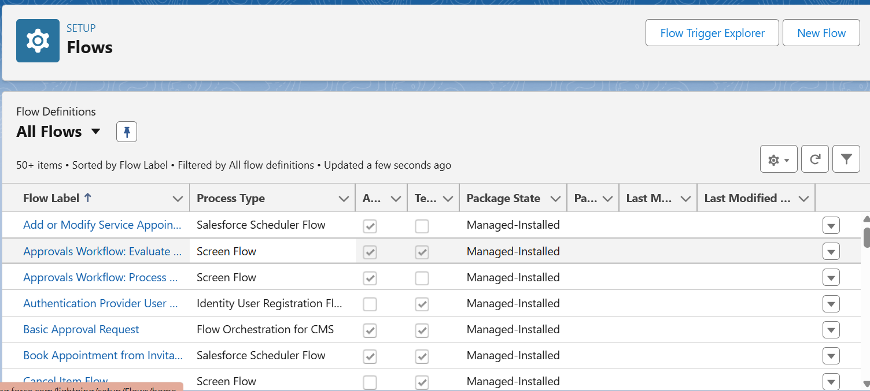

# 6. Email Alerts & Notifications

* • Email Templates for:
* - Order Confirmation.
* - Order Dispatched.
* - Delivery Completed.
* • Custom Notifications (in Salesforce app):
* - Sales team alerted when new order is placed.
* - Inventory Manager alerted if stock < reorder level.